Developing a New Partnership: Collaboration between Museums and Schools
GUO Meixia, Deputy Director of Publicity and Education Department, the Palace Museum

ABSTRACT
Education, as an important function of museums, has drawn increasingly more attention from the society and expanded vastly into the collaboration between museums and schools. On the one hand, schools are more willing to take extracurricular courses in museums, especially after the policies of strengthening out-of-school education and encouraging the use of social resources, including the resources from museums, were issued. One the other hand, museums have received more student visitors since the free admission policy was adopted, which impels them to place higher stress on education and provides richer education activities. In terms of contents and forms of the collaboration between the Palace Museum and schools on education activities, the Museum is trying multiple ways to meet the demands from schools, like museum visits, theme activities, course series, course dispatch, and worksheets. Textbooks, PowerPoint documents, videos and other supporting materials were also prepared based on the characteristics of students, which lead the collaboration to a new level. In the process of establishing a new partnership, communication between museums and schools, the shift of the roles of educators and teachers, and the productization of education programs are the premise and basis of large-scale school-oriented museum courses, and they will endow the collaboration with better quality, higher efficiency and greater influence.

Key words: museum, school, collaboration between museums and schools, partnership

Shortly after he built the first modern museum in China in 1905, Zhang Jian had touched upon the collaboration between museums and schools, believing that the museum can “be a place for reference and experimentation to talented people who undertake education so that they can synthesize the past and present, search and explore for answers.” Thus museums are important institutions of social education and efficient complement to school education.
Up to now, as one of the important functions of museums, education has drawn increasing attention from society. The collaboration between museums and schools in education has been more and more extensive. On the one hand, the system of compulsory education has come to stress and increase off-campus education and, particularly, put forward the specific demand of utilizing museum resources to carry out off-campus activities. On the other, the investment made by—and the attention paid to—education by museums have increased substantially, which offers greater room for the development of education targeting the young. Facing such opportunities, museum staff must meet the challenges, seek to bridge the gap between the soaring demand of school programs and the existing programs of museums which are struggling to meet the demand, and strive to improve the capacity of museums for developing educational resources and increase their manpower input into education. However, the strengths at their own disposal are very limited; museums must actively develop a new partnership with schools.

I. Policy Environment of Museum-School Collaboration
In recent years, the authorities of school education have set forth specific requirements on the use of museum resources by schools. Take Beijing as an example, the Publicity Department of the CPC Municipal Committee, Municipal Commission of Education, education research institutions and all district and county education commissions have drawn up multiple documents requiring schools to go out of class and into communities and to make good use of museums to deliver off-campus education to students.
1. Great Community Class
“The Great Community Class for Beijing Secondary and Primary School Students” by full name was jointly launched by the Publicity Department of the CPC Municipal Committee, the educational authorities and some pertinent resource providers. The main purpose is to make use mainly of community resources to carry out community education and teaching programs suiting the traits of students and fitting with school curriculum. Schools or individual students may choose to participate in these programs on their own. Information on resources is provided on certain websites. Resources within the educational system consisting of institutions of higher learning, regular secondary and primary schools, vocational secondary schools, etc. are combined with abundant cultural and natural resources in Beijing, with social resources of patriotic education bases, public cultural facilities, scientific research institutions, enterprises, rural areas and communities, to provide free or inexpensive conditions, safe environment and suitable educational & teaching contents, and to create conditions for investigative learning, community service, social practice and subject-specific teaching activities.
The Great Community Class Program embodies the principle of service. Firstly, it serves students by providing spacious places for off-campus educational activities and catering to the diverse needs of students for social experience activities; secondly, it serves education and teaching by offering curriculum resources of teaching practice to school curriculum reform; and thirdly, it serves public facilities by helping them better fulfill their educational functions and supporting them to educate minors and perform public service in a purposeful, planned fashion.
2. The Four Tours Program
The Four Tours Program, which requires that “every student observes the flag-raising ceremony on Tiananmen Square at least once, and pay at least one visit to the National Museum of China, to the Capital Museum and to the Museum of the War of Chinese People's Resistance Against Japanese Aggression”, was officially laid down in The Guidelines of Beijing for Cultivating and Practicing Socialist Core Values in Secondary and Primary Schools issued by the General Office of the Municipal Government in September 2014. It is in fact part of the One-Ten-Hundred-Thousand Program aimed at promoting secondary & primary school practice and experience activities. Besides, every student should participate at least ten collectively organized public-service events, watch at least 100 good films and TV programs, read at least 100 good books, learn about the deeds and sterling character of at least 100 heroes and advanced figures both in China and abroad. One thousand extracurricular instructors should be trained and hired by at least 1,000 public facilities including libraries and museums. All these are closely related to the effort to improve the Community Class construction mechanism. It requires the government to better utilize social resources by means of service procurement so that “no less than 10% of classwork of every subject is completed with guidance at the Great Community Class”.
3. Scientific & Technological Innovation Talent Development Program for the Youth
With the implementation of education and teaching reform in recent years, the educational system starts to stress the mode of developing young innovative talent. Beijing Academy of Educational Sciences, as the research institution specialized in education and teaching, has set up Beijing Adolescents’ Academy of Scientific and Technological Innovation, which strives to train scientific and technological talent with innovative consciousness. Correspondingly, it has also set forth the Soaring Program targeting secondary school students and the Eyases Program targeting primary school students. Both have prompted schools to finish more of their subjects off campus via student participation, investigation, research and experimentation. That means, off-campus education has become an important, or even indispensable, part of youth ability development.
4. District-level Off-campus Education Programs
Apart from programs at municipal level, i.e. the Great Community Class Program, Four Tours Program and Scientific & Technological Innovation Talent Development Program for the Young, the districts and counties in Beijing have also made educational plans different in name but similar in nature. For instance, the Blue Sky Program launched by Dongcheng District in 2005 combines school and community educational resources to provide students with a pool of resources, an activity book, an information management platform, an evaluation system, and a management center of extracurricular activities. In this way they have built a “large community campus without walls” and innovated a new mode of extracurricular activity management, which utilizes social resources to serve curricular teaching and promotes effective curricular and extracurricular coordination and integration. Xicheng District also has the Urban Youth Palace Program, which introduces off-campus resources for off-campus courses on art, PE, science & technology so as to improve students’ comprehensive practical abilities.
5. Hours and Funding of Off-campus Education
To match the above-mentioned educational policies, the educational authorities require school education to expand into communities. Alongside the use of social resources for educational and teaching activities, reform of the school curricular system is also going on. The first thing to do is to set aside certain hours from the traditional circular system for off-campus activities. In principle, 10% of the class hours in every semester are to be autonomously used by schools in the form of comprehensive practice. Thus schools start to pursue social resources actively in order to complete designated teaching tasks. Museums, as patriotic education bases which not only meet the requirements of space for student activities, but also are universally “educational”, have become a major partner with which schools seek to collaborate. Besides, in the process of circular reform, schools also develop school-specific school-based curriculum. Museums in their neighborhoods are usually their partners on school-based curriculum.
In terms of funds, the educational authorities have offered adequate guarantee. The policies of the Great Community Class, Four Tours Program and Scientific & Technological Talent Development Program for the Youth all go with earmarked financial support. In the Great Community Class framework, the Municipal Education Commission appropriates per-student funds to schools. Every semester, 300-500 yuan are committed to each student on average for off-campus educational curriculum. The Soaring Program and Eyases Program also allot per-student funds to schools. As for the Four Tours Program, the educational authorities directly earmark funds for tours. In general, these funds can be used to cover transportation, materials, lectures, expert invitation, publishing and printing etc. entailed in off-campus curriculum organization.
Under this policy context, both the educational authorities and schools are motivated to lead students onto museum tours, which go far beyond the traditional “receive-and-explain” pattern museums typically employ for student groups. Instead, they expect museum programs to go further and meet the needs of school curriculum, thus achieving the goals of comprehensive off-campus practical curriculum integrating with multiple disciplines—which not only develop students’ social practical abilities and innovative thinking, but also satisfy teachers’ demand for curriculum. Due to the Four Tours Program, the National Museum of China, Capital Museum and Museum of the War of Chinese People's Resistance Against Japanese Aggression have seen an upsurge of school tours. Besides regular tours, they are also trying to provide more engaging, more “educational” themed programs and activities. However, the constraints of reception capacity, difficulty in reservation, etc. are also testing the abilities of museum educational departments. To address these problems, other museums should not just be onlookers, but take part in the interaction between schools and museums.

II. Statistical Analysis of Free Admission to Museums and Free Admission for Students to the Palace Museum
Museums, which offer free admission, have obviously been ahead of the educational authorities, which require secondary and primary schools to carry out off-campus practical classes and build the Great Community Class. It took a period of time for Chinese museums to first pilot and then fully implement the free admission policy. In 2002, the National Museum of Chinese History first released its regular “free day” policy. Every Friday, it would offer free admission to students between 13:00-15:00. Following its example, other museums also started to try free admission. In 2004, the 16 museums under Beijing Municipal Administration of Cultural Heritage collectively began offering free admission to local secondary and primary school students. Under these circumstances, the Palace Museum declared that starting from March 1, 2004, secondary and primary school students could enjoy free admission to the museum after reservation every Tuesday (holidays excluded).
Free admission to museums, as a policy, was fully implemented in 2008. This has created a new situation of interaction between museums all over China and the public. The public has increasing demand on the educational function of museums and museums feel increasingly obliged to educate the public. Education targeting students is flourishing in this context.
Take the Palace Museum as an example, though as a historic site museum it does not fit into the category of free admission, as a national patriotic education base, it is bound by duty to offer certain favorable policies to secondary and primary school students in the broad context of free museum admission. Therefore, every Tuesday has been made a day of free admission to student groups which have made an appointment in advance.
The past three years, i.e. 2013-2015, saw the total number of teachers and students who benefited from the free Tuesday policy amount to 123,049. The statistics for every month is as follows (Chart 1):

Chart 1: Number of students received every month from 2013 to 2015

From the chart, it can be seen that student tours organized by schools, besides the summer vacation, mainly concentrate in March, April and May, and then in September, October and November, which are relatively appropriate for school-organized museum practical activities amid semesters.
Students received in the two semesters are mainly secondary and primary school students, as well as some college, international and vocational school students. Secondary school students, as the mainstay, account for 71%; primary school students, 21%; college and other students, only 8% (see Chart 2).

Chart 2: Statistics of student groups in different types who visited the Palace Museum on Tuesdays for free from 2013 to 2015

To get a clear picture of the numbers of secondary and primary schools which chose to visit the Palace Museum, we have sampled the statistics of Tuesdays from 2014 to 2015. The results are as follows (Table 1):
Sampling statistics of the year 2013
Date (y.m.d) | 2013.3.19 | 2013.4.9 | 2013.5.21 | 2013.9.24 | 2013.10.22 | 2013.11.26 | Total
Number of secondary schools | 3 | 5 | 4 | 5 | 7 | 5 | 29
Number of primary schools | 3 | 4 | 2 | 0 | 0 | 2 | 11
Sampling statistics of the year 2014
Date (y.m.d) | 2014.3.25 | 2014.4.15 | 2014.5.20 | 2014.9.30 | 2014.10.21 | 2014.11.4 | Total
Number of secondary schools | 3 | 3 | 5 | 4 | 6 | 6 | 27
Number of primary schools | 1 | 3 | 4 | 2 | 1 | 0 | 11
Sampling statistics of the year 2015
Date (y.m.d) | 2015.3.31 | 2015.4.21 | 2015.5.12 | 2015.9.22 | 2015.10.27 | 2015.11.10 | Total
Number of secondary schools | 7 | 3 | 6 | 2 | 9 | 5 | 32
Number of primary schools | 0 | 3 | 2 | 1 | 1 | 1 | 8
Table 1: Sample statistics of secondary and primary schools which benefit from free admission to the Palace Museum from 2013 to 2015
The results show that of students who enjoyed free admission to the Palace Museum, there is a great discrepancy between secondary and primary schools (see Chart 3). The ratio of secondary to primary schools was 29:11 in 2013, 27:11 in 2014 and 32:8 in 2015. That is to say, of all secondary and primary schools which organized free tours of the Palace Museum, secondary schools far outnumbered primary schools, about three times more. The statistics indicates that secondary schools are more prone to organize tours of the Palace Museum than primary schools. Therefore, as museums collaborate with schools on museum-based educational programs, more attention should be paid to secondary school students; more educational programs suiting secondary school students’ learning abilities and the traits of secondary school subjects should be designed.

Chart 3: Comparison of Secondary and Primary School Participation from 2013 to 2015

In addition, experience has shown that primary schools are more willing to organize on-campus activities or classes in collaboration with museums. In so doing, they can free themselves from concerns about students' safety, parking, etc.

III. Practices of Museum-School Collaboration
The above-mentioned policies encouraging schools to collaborate with museums to develop comprehensive practical curriculum and the context of free admission to museums have jointly contributed to various collaboration between schools and museums. Take the Palace Museum as an example, the recent years have seen various forms of school-oriented educational programs.
1. Themed Tours
Themed tours are an educational program closest to traditional guided museum tours. A themed tour is often led by a guide familiar with the contents (exhibition, venue), who explains to students and guides them to appreciate and discuss under the designated theme. Take the Palace Museum as an example, if the theme is designated as “porcelain appreciation”, then the tour is closer to traditional guided tours. But if the theme is designated as “dragons in the porcelain hall”, then it becomes more prominent. Different themes result in different focuses of tours. For example, the theme “dragons in the porcelain hall” guides students’ attention to dragon patterns. Consequently, students are likely to neglect forms and functions of chinaware and pay attention directly to patterns. Guides, or educational personnel, generally prepare for the tour in advance, compare images of dragons in different dynasties and guide students to draw their own conclusions. In form, themed tours put more emphasis upon students’ participation and interaction and, often with tasks set in advance, are more purposeful. For example, the tour “Search for Porcelain Shards” incorporates contests such as “Crack Mysteries by Piecing Together Porcelain Shards” (Fig.1) to arouse students’ interest. Workshops, presentations on tours, etc. are sometimes arranged. Such tours require that museums communicate with schools in advance to learn about goals of school curriculum and students’ knowledge base, interests, etc. The relationship between students and museum educational staff is collaborative rather than unidirectional. It is very beneficial to the improvement of students’ comprehensive abilities of observation, analysis, verbal expression and teamwork.
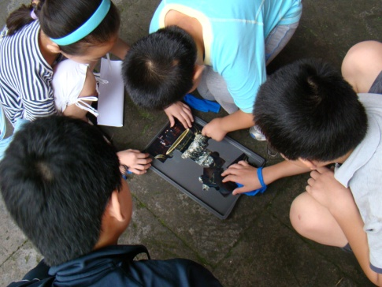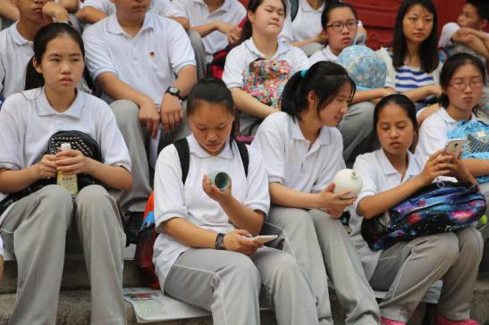
Fig.1: Themed tours of the Porcelain Hall
2. Themed Activities
The development of the educational function of Chinese museums in recent years manifests itself, for one thing, in the upsurge of themed activities rich in content and diverse in form, apart from regular tours. What distinguishes themed activities from themed tours is that the former are often independent from the environment and collections of exhibition halls or the museum environment. Take themed activities of the Palace Museum as an example, though most of them by design incorporate a certain exhibition or a certain themed collection of cultural relics, in practice they are not so dependent on the exhibition or the museum environment, but can be performed independently. It is especially convenient for them to be delivered to schools, where they are completed within the framework of class curriculum. Cases in point include “Chao-zhu (Court Necklace) DIY”, “Draw a Dragon Robe by Yourself” (Fig.2), “Transforming Porcelain Vases” (Fig.3), “Cute Dolls of the Eight Banners” (Fig.4), “Make a Rubber Stamp” (Fig.5), etc.
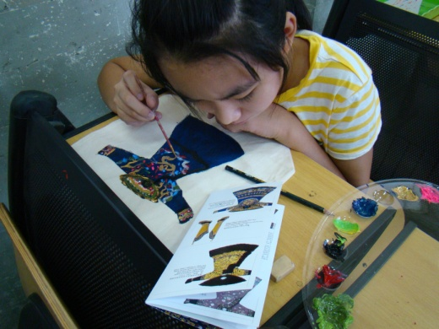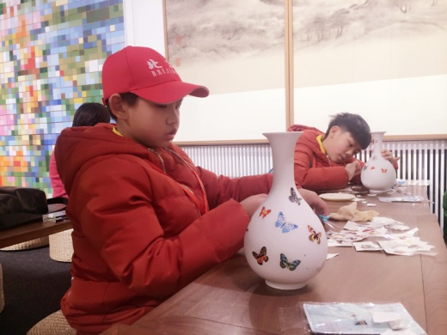
Fig.2: Drawing a dragon robe Fig.3: Decorating porcelain vases with butterfly-shaped water stickers
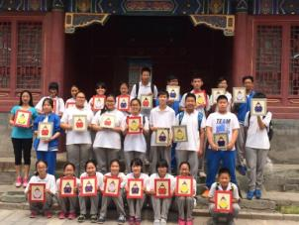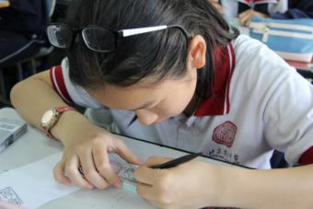
Fig.4: “Cute Dolls of the Eight Banners” educational activity Fig.5: Carving a rubber stamp

Unlike school-organized activities, museum-organized themed activities stress student participation and experiences and emphasize practical abilities and the dialogue between students and educational personnel. Themed activities make it easier for educators to make use of “a wide range of interactive forms, encourage schoolchildren or other participants to take an active part and use all the senses and inspire them to express themselves”. Sometimes, they “refrain from explaining everything to them [students]; instead, let them discover, describe and experience what they see.” Generally they are carried out by combining themed lectures and hands-on activities. An activity lasts about 150 minutes. Such a time length makes it possible to be completed with a museum visit within half a day. At schools, it can be finished in two class hours or a lengthy lecture. Such activities often go with supplementary teaching materials, including courseware and video materials for teachers and material packages for students. In the past several years, packages of materials provided by the Palace Museum are increasingly standardized and professional. Generally speaking, a package of materials provided to students often contains packaging, a manual, a learning card and main materials. This has almost become learning materials schools customize for their students to use at museums, providing convenience to both museum educational personnel and school teachers.
3. Serial Curriculum
In the development and evolution of pedagogy, there have been different definitions of curriculum. For instance, there have been assertions that curriculum is textbooks, or activities or experience, represented respectively by John Amos Comenius, John Dewey and Ralph W. Tyler. In the three theoretical frameworks, the contemporary concept of curriculum often refers to the sum of courses students are supposed to study at school, its progress and arrangement. It has a broad sense and a narrow sense. In a broad sense, curriculum means the sum of the educational contents the school chooses to achieve the goal of training and its process. It includes all subjects the school teaches and purposeful educational activities executed in a planned fashion. Curriculum in a narrow sense refers to a certain subject.
Obviously, if thus defined, curriculum takes place in “school”! However, this does not hinder museums from carrying out museum educational curriculum. The premise is the collaboration between museums and schools. If a museum educational activity or subject is designed for the school’s teaching objectives, then it naturally becomes part of the school’s educational curriculum.
What the serial curriculum focuses on is not an independent themed activity, but the connection between independent activities. For example, from March to June, 2016, the Palace Museum and Beijing No.31 Secondary School jointly launched an interesting elective, “Discover the Forbidden City” (Fig.6). Students could apply for the elective in advance. Eventually 18 Grade 7 students finished the required 24 hours by attending the course 12 times. It was the first time for a museum to open a course spanning a whole semester at school. Though there are independent themed activities, when the courses were planned, consideration must be given to the wholeness and coherence of the courses with an overall goal. Thus we set the overall goal of the serial curriculum as “to let students learn about and discover the Palace Museum, arouse their interest in exhibitions held in the Palace Museum and know how to ‘read’ museum collects”. Therefore, the courses started with the fact that the Forbidden City is a museum; next its architecture and history are described; then there are subject- or collect-specific classes; and the curriculum is concluded with instructions on how to appreciate an exhibition and read collects, display of students’ works and their representations in the semester. The course spanning the entire semester is interesting and intuitive, with topic-focused learning, instructions on methodology and reflections on questions; while expanding students’ knowledge, it also helps them develop practical abilities, verbal dexterity, thinking ability etc.
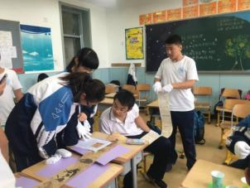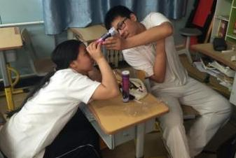
Fig.6 Elective on the Forbidden City at Beijing No.31 Secondary School
4. Curriculum Delivery
Curriculum delivery is one of the preferable ways of museum-school collaboration. Two types of contents can be delivered: first, the entire activity is delivered and educational personnel from museums execute the course; and second, courseware and material packages are delivered and museum educational personnel directs school teachers to finish the course independently.
To deliver a course, the museum needs to communicate with the school’s teaching management to determine the hours, targeted classes, number of participants, etc. Generally, activities for all classes of a grade can be finished within a day. For instance, we once delivered the “Cute Dolls of the Eight Banners” Program to the eight Grade Five classes of a school. In one morning and afternoon, three instructors finished all the classwork. Teachers and students of each class were able to experience the characteristics of the Palace Museum curriculum.
To deliver courseware and teaching materials alone, the program will have more proximity to a certain subject. More often than not, there is a need to contact teachers of the subject and send teaching contents to them in advance. Then museum educational personnel should communicate with school teachers, discussing and answering questions. The teachers finish the teaching tasks in classes they are respectively responsible for. This form, which has less to do with the school’s administrative management and requires less curricular arrangements, is more flexible and more convenient. As the teachers are more familiar with students, it is more convenient to adjust teaching contents according to students’ needs. This year the Palace Museum delivered the course “Paper Penholders that Impart Knowledge”—which suits students of Grade 1-3—and its material package to art teachers of a primary school, who carried it out for over 350 students in 9 classes (Fig.7). If this course is carried out at the Palace Museum, generally it can only take place on weekends. Then it requires at least 10 half-days to finish. It is evident which way is better. Besides, we also sent coloring materials focusing on the Exhibition on Celebrations of Emperors’ Birthdays to 20 schools for more than 4,000 students and guided specialized art teachers to finish them. The delivery of the course brought to play in a remarkable fashion the role of teachers as instructors and the creativity of students, who create many excellent works beyond the imagination of museum staff.

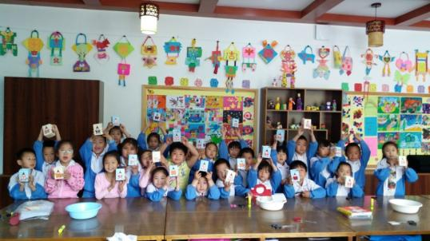
Fig. 7 Teaching materials of the Palace Museum sent to students for DIY under teachers’ instructions
5. Worksheets
Worksheets are widely used in European and American museums. In China, though the form is adopted, they are more often seen in science and technology museums. Of historical, cultural and art museums, Hunan Museum is probably among the first to use them. Worksheets are mainly tour-guiding, self-learning materials which museums design to help teachers or parents guide students. For schools, they can cover the shortcomings in teaching and content as extended textbooks designed for essential-qualities-oriented (EQO) education, which not only enrich students’ basic ability but also nurture students’ attitude to self-motivated learning. At museums, they are extension of exhibitions, and can make up for the shortcomings of exhibitions, highlight the nature of “object-based learning” of museums and guide students to observe, analyze and investigate objects.
As more and more schools choose off-campus curriculum carried out by museums, worksheets are undoubtedly a good choice, particularly for the Palace Museum, because they make it possible to deliver concurrent museum classes to several or even a dozen of classes.
The Palace Museum has large open areas and various themed exhibitions. To design worksheets suitable for volunteers or school teachers to guide students is a school educational program launched by the Palace Museum publicity and education department. This July, eight classes of a secondary school visited the Palace Museum to take part in eight courses of different themes in different forms, laying the foundation for our launch of this program. As experiment has shown, two worksheets combining the themed exhibition in the porcelain hall and the regular tour of the Imperial Garden generated desirable results hardly achievable for regular guided tours. (Fig.8 and Fig.9)
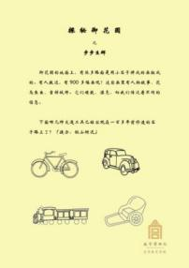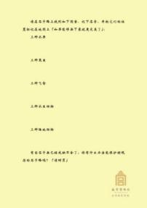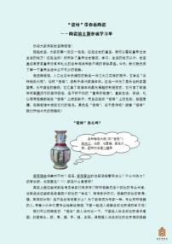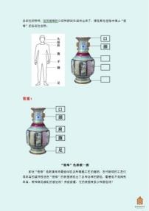
Fig.8 Worksheets for the Imperial Garden
Fig. 9 Worksheets for the Porcelain Hall
By asking questions, worksheets guide students to explore independently and sum up and present results via work demonstration, oral report, discussion & evaluation under the guidance of educational personnel. They can effectively improve students’ comprehensive learning abilities.
6. Supplementary Teaching Materials
In teaching practice, however museums collaborate with schools, supplementary teaching materials, as products of the collaboration, are certain to be produced. For specific courses or activities, museums’ school-oriented educational programs can compile teaching materials and portable and easy-to-copy courseware.
As for teaching materials, schools generally have textbooks for students and reference books for teachers. When it comes to museums, in the recent years, as museum-school collaboration grows, some museums and schools have jointly published curriculum textbooks. The Palace Museum published as early as in 2011 a collection of educational activities fairly popular among students-- Learn Court Handicraft Happily. The book is intended to provide students or teachers with materials on Palace Museum curriculum for their reference so that they can conveniently learn about the contents of the curriculum and how to implement it. Teachers can adapt its contents into classes suitable for the traits of their students by themselves.
As for courseware, all educational programs and teaching activities of the Palace Museum have formed, in the course of repeated implementation and constant improvement, full-fledged teaching courseware, including PPT documents and teaching videos, which help educational personnel implement the curriculum, explain and impact knowledge, organize activities, etc. (Fig.10 and Fig.11). The courseware can be provided directly to school teachers as their supplementary teaching materials which help them copy the museum curriculum to classes. The above-mentioned “delivery of curriculum” involves delivering courseware to teachers and teaching material packages to students, so the teachers can guide their students to complete the courses.
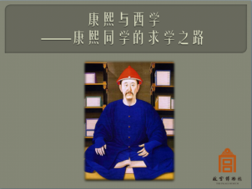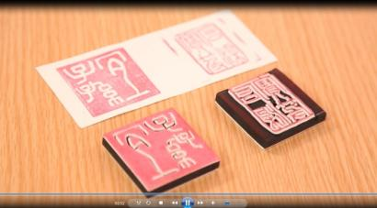
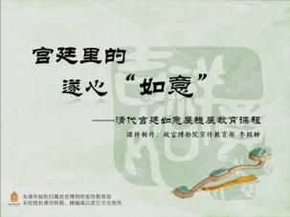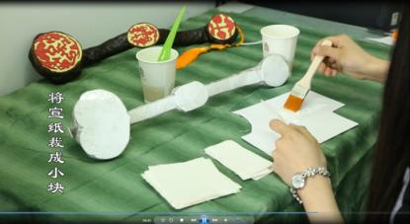
Fig.10 Covers of PPT Documents of Palace Museum educational programsFig. 11 Teaching Videos of the Palace Museum educational programs

IV. Advantages of Schools and Museums in Educational Resources
After discussing practices of museum-school collaboration, let’s talk about resources museums and schools have for their collaboration. As a matter of fact, museum-school collaboration is moreabout resource sharing and advantage complementarity between the two parties. It is more beneficial to sustainable collaboration to identify their respective resource advantages.
1. Advantageous Resources of Schools
Resources of schools consist first of all in students. Students, organized in classes, are roughly of the same age and have nearly identical knowledge and literacy levels. As they study together for most of the time, they are familiar with, understand and trust each other. They are aware of certain students’ strengths or weaknesses in certain fields. Students generally do not study on their own initiative, but complete their learning tasks bound by social circumstances. This is different from the education programs that museums provide, which is an interaction between strangers.
From the perspective of museum-school collaboration, it is precisely because students’ relative constancy, mutual familiarity and similar knowledge level that when museums design school-oriented programs they have clearer objectives and are easier to grasp the difficulty and establish links between museum programs and students based on past experience. Moreover, schools organize teaching by semesters and school years. The end of every school year heralds the start of a new cycle. This makes it possible for school-oriented programs of museums to be implemented repeatedly and improved continuously.
Secondly, resources of schools consist in teachers. Judging by educational practice of the National Museum of China, museum educational personnel are far less experienced in teaching than school teachers. In terms of textbook research and teaching plan preparation, knowledge base and methods, consolidation training and teaching evaluation, school teachers, who have regularly worked in a full-fledged educational system, have fairly rich experience and skills. Therefore, it is the wisest choice to choose teachers as partners when museums carry out educational programs. Besides, teachers are much more familiar with students than museum educational personnel and can directly incorporate the contents of museum curriculum to students at their classes, thus saving the trouble of great adjustments of teaching schedules for museum curriculum.
2. Advantageous Resources of Museums
Museums have two major types of advantageous resources: First, places/venues of museums; second, collections of museums.
As far as places/venues are concerned, when students come to museums for learning activities, one of the great differences lies in the environment. The venues and exhibition spaces of museums built at historical sites or exhibited as works of art are often the most appealing to students. Museums have unique interiors and exhibition spaces, different from the class environment at school, where students can discuss freely, observe or rest; meanwhile, they can also come into contact with various strangers. So it is not only a process of learning, but also an important way of socializing.
As for the collections, they are one of the aspects students are most concerned with when they visit museums, which constitute the greatest difference between learning in museums and at school. “Schools concentrate on printed words, pictures, and other two-dimensional materials for their instruction.” In museums, most collection are various “physical objects”, whose three-dimensional images can bring students rich sensory experiences so that they can observe from different angles and acquire different knowledge and experience by engaging multiple senses.
V. Thinking on Museum-School Collaboration
The effective collaboration between museums and schools, as siblings in education, can promote the coordinated development of museum and school education despite their great differences. The Palace Museum has been inspired in the following aspects during its educational collaboration with schools:
1. Full Communication Between Museums and Schools
Unlike museum-initiated family education and continuing education, when the museum collaborates with the school, full communication between the two is necessary. The school has fairly definite goals of education set according to students’ age. It can set aside some periods of time when educational activities can be carried out in a collective fashion. Meanwhile it has concerns about sending students off campus to study. All these require thorough communication between museums and schools in advance so that the former can provide programs meeting needs of the latter, make plans and resolve relevant issues. Perhaps, not all issues can be resolved, but at least the two parties can build up mutual understanding and trust in the process. Through full communication, museums and schools can establish common goals of education, decide on reasonable forms and bring about results of education with which both are satisfied. Therefore, communication is crucial in developing partnerships with schools.
2. Role Switching of Teachers and Museum Educational Personnel
Museum educational personnel carry out educational programs for schools; school teachers deliver courses prepared in advance in the frameworks of museum educational programs—there seem to be no distinct differences between the two. In reality, as a large number of student visitors flood in, Chinese museums need to consider the role exchange between school teachers and museum educational personnel. Museums in the United States faced nearly the same situation about 25 years ago. While museums, elated at the attention paid by schools, actively developed school-oriented educational programs, they were also under tremendous pressure. The pressure was first exerted on the number, time and energy of museum educators. To address this, Boston Museum had adopted the practice of giving up developing school programs and focusing on improving tour environment. However, given the realities of Chinese museums, we are reluctant to make such a risky attempt. Therefore, some role switching of teachers and museum educators is a measure that may help tackle the lack of museum educators in museum-school collaboration. It is not uncommon that museum educators enter school classrooms to deliver museum curriculum. Such practice is, after all, of very limited coverage. Therefore, it is more significant to turn school teachers into “museum educators”, who learn about the museum’s collection and the culture behind them, and design courses for teachers’ use and application. Generally speaking, in the initial stage of museum-school collaboration, museum educators may turn into school teachers to help schools finish museum educational curriculum. When the programs are relatively mature, more effort can be made to encourage school teachers to turn into museum educators to facilitate museum-school educational collaboration. With the role switching between teachers and museum educators, true partnership can be established between museum educators and school teachers so that they may support each other and play their roles together.
3. Development and Utilization of the Collection and Productization of Educational Programs
As said above, the collection is the advantageous resources of the museum. Collection-based three-dimensional learning materials are one of the typical features which distinguish them from teaching materials at school. In the collaboration between museums and schools, it is essential to develop and utilize the collection more effectively. Museum educators, who have long worked in museum settings and had direct contact with researchers in various fields, are in a better place to learn about the collection, choose relevant educational topics, implement themed educational programs and provide them directly to schools, so the schools can use them to design school curriculum and carry out subject-specific museum visits.
Furthermore, due to the great emphasis put by the educational authorities on off-campus education, and on museum education in particular, Productization of educational programs may be one of the paths today for educational development of Chinese museums. In the context of China, though productization of educational programs tends to be associated with commercialization of education, in the dimension of museum studies, market and products should never be avoided. American museums, in fact, have treated various exhibition-related educational programs as “products” and actively promoted the development of new products, such as art and craft exhibitions, story-telling, museum holiday events and family-oriented activities. Against this background, packages of teaching materials for educational activities are naturally “products”. Take the Palace Museum as an example, it has made fairly good achievements in the past year in making educational programs it designed and developed in the last decade into products. From “Court Necklace DIY”, to “Cute Dolls of the Eight Banners”, to the Imperial Garden Worksheet that is being designed, to the Rubber Copies of Emperor Qianlong’s Five Seals, the participation of cultural and creative talent has contributed to a full-set model of themed educational products of the Palace Museum, consisting of covers, manual, learning cards and material packages (Fig. 12, Fig.13, Fig.14, Fig.15), which can, as a merit, be conveniently brought into schools or used at suitable spaces in the museum. This has greatly saved museum educators’ time and freed them from the trouble of having to buy materials and tools many times and going through complicated financial procedures. They can thus commit themselves to the design of more educational courses and contents.
Practice has proven that a full-fledged package of teaching materials makes it possible to organize large-scale educational programs with a participation of 200-300 people. This is unimaginable when museum educators have to prepare material themselves. China has a large number of students. They come to museums in a concentrated manner. Museum educators, given their small number, can hardly meet the demand. Productization of educational programs can, to a certain degree, resolve the problem, expand the influence of museum education at school and enable students several times more than in the past to have access to good museum educational programs.
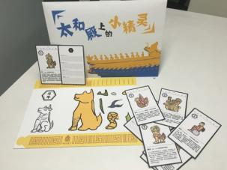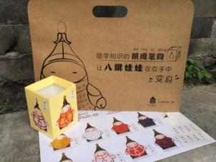
Fig.12 Educational materials for “Ridge Figures of the Forbidden City”
Fig.13 Educational materials for “Eight Banners Themed Penholders”
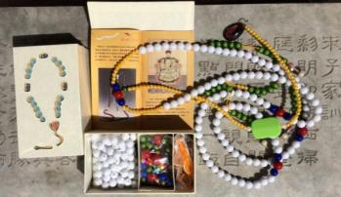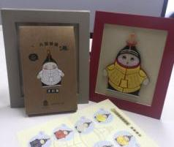

Fig.14 Educational materials for “Court Necklace DIY”
Fig.15 Educational materials for “Cute Dolls of the Eight Banners”

Finally, I’d like to get back to the topic “new museum-school partnership”. Museum-school collaboration has never been a new thing. It has always been hand in hand with the educational function of the museum. However, in the current context of school education reform and new policies, museum-school collaboration has made breakthroughs in quantity, quality and scale, marching toward a “new” direction of large scale. To meet the new requirements, new partnerships must be built on the basis of communication, understanding and mutual help. Museums and schools are partners and friends; instead of being preoccupied with their own things, they cooperate and work together. Only by thinking and exploring continuously based on their own and others’ experience and practice can they constantly improve the quality, efficiency and influence of museum-school educational programs and make their work more efficient and rewarding.

Quoted from LIANG Jisheng, A Brief History of Chinese Museums Before 1949, Chinese Museum, 1986 (7).
It mainly refers to the Four Tours Program, which will be discussed in detail later.
See Plan of Beijing Municipality for Building the Great Community Class for Secondary and Primary School Students issued in August 2008 and officially put into effect on September 1, 2008.
See Article 12, The Guidelines of Beijing Municipality for Cultivating and Practicing Socialist Core Values in Secondary and Primary Schools, issued in September 2014.
See Article 12, The Guidelines of Beijing for Cultivating and Practicing Socialist Core Values in Secondary and Primary Schools, issued in September 2014. Here it needs to be stressed that “no less than 10% of classwork of every subject should be completed under the guidance of the Great Community Class”. Thanks to the requirement, when a school organizes its students to take part in an off-campus activity, more often than not, subjects need to be combined into an integrated course while embodying subject-specific goals. This is crucial when museums set goals for school education programs they develop.
That off-campus practical activities for students need meet teachers’ demand has always been a topic that should not be shied away. “They [schoolchildren] generally view their visit as a holiday from school. Yet the teacher must justify the trip using an educational rationale.” The museum must find a way to satisfy the teacher while making the experience enjoyable enough to encourage a lifelong use of museums in children. See Elaine Heumann Gurian: Civilizing the Museum, P140, Routledge, 2006.
See the February 24, 2004 issue of Beijing Evening News. The policy is still in effect, which requires a school to provide a letter of request for group reservation. To regulate the total amount of visitors, the quota for students who enjoy free admission was initially 1,000 and later raised to 2,000.
See The Notice on Free Admission to Museums and Memorials Nationwide. The notice prescribes that free admission shall be granted at all public museums and memorials under cultural and cultural heritage authorities at all levels nationwide and at all patriotic education bases nationwide. This, however, does not apply to historic buildings and historic site museums. Minors, the aged, soldiers in active duty, the physical disadvantaged and the needy groups continue to enjoy favorable policies. If a museum or memorial holds a special (temporary) commercial exhibition, it may determine the admission rate according to the actual circumstances.
The numbers of the three years are respectively 53,411, 37,745 and 31,893, which shows a decreasing tendency. As a matter of fact, the free Tuesday admission has not changed. However, because the educational authorities have allotted ample funds for extracurricular practical activities, schools not only set store by free admission, but also start to pay attention to course content.
See the Palace Museum: Learn Court Handicraft Happily, p112, Forbidden City Press, 2011.
Some of these activities combine with exhibitions, some with cultural relics, and some with a theme close to the Palace Museum. All these activities have always been carried out at school classes or children activities in communities and are well received. Such separate activities are particularly fit to be carried out in schools to enrich students’ comprehensive practice, increase their knowledge of museums and arouse their interest in visiting museums.
Trans. ICOM-China, Chinese Society of Museums: Running a Museum, p182, Phoenix Publishing & Media, Inc., Yilin Press, 2010.
Take the delivery of the package “Paint Butterflies to Form the Character for ‘Longevity’” for example. Many butterflies are involved to form the character shou or “longevity”. Because die, the Chinese character for “butterfly”, is homophonous to the Chinese character for “70-80 years of age”, the butterfly has the symbolic meaning of “longevity”. As a teacher instructed students to create their works, she guided them to learn more about Chinese auspicious patterns and traditional culture. Apart from the butterfly, students also pointed out that the peach, pine tree, crane etc. all stand for longevity and that the bat and gourd stand for good fortune. Thus the teacher proceeded to ask students, “Now that we can paint butterflies to form the character for ‘longevity’, can we also paint gourds or peaches to form shou or the character for ‘longevity’ as well?” Her guidance resulted in far more diverse works than presented by the museum courseware.
Hunan Museum adopted Worksheet for Cultural Relics Exploration fairly early so as to encourage students to carry out object-based investigative learning. See: Xue Chao, Object-based Investigative Learning--A Practice Promoting Primary School Students’ Comprehensive Qualities, The Collection of Papers in Museum Studies from the 2012 Annual Meeting of Hunan Provincial Society of Museums and the Symposium on the Collection and Protection Management of Museum Cultural Relics, November 2012.
Meng Qingjin: Learning Sheets: An Effective Tool for Museum-School Educational Collaboration, Chinese Museum, 2004-3.
The National Museum of China has been a leader in museum-school collaboration. Based on museum-school collaborative curriculum, it has compiled Traditional Chinese Culture: A Guide to Museum Comprehensive Practical Abilities-Oriented Curriculum and textbooks for students, which have been published in 2015 by the People’s Fine Arts Publishing House.
Elaine Heumann Gurian: Civilizing the Museum, P138, Routledge, 2006.
In 1982, numerous student groups flooded into Boston Children’s Museum, which made museum educators more like teachers than educators. As its director described, “…school group programming took up too much time and turned my staff into teachers rather than museum educators.” See: Elaine Heumann Gurian: Civilizing the Museum, P147, Routledge, 2006.
Neil G. Kotler, Philip Kotler et al., trans. Pan Shouyong, Museum Marketing and Strategy, p189, Beijing Yanshan Press, 2006.

