The Forbidden City under the archaeological view
Archaeology Institute of the Palace Museum
Li Ji

Archaeology Institute of The Palace Museum was founded on Oct.23rd 2013.Major themes of our research are: Archaeological activities in relation to the Forbidden City, archaeological activities in relation to imperial ruins and remains, cooperation with provincial/municipal archaeology institutes, international exchange and cooperation, archaeological research into artifacts and other items from the collection of the Palace Museum, and thecooperative multidisciplinary research. Among them, Archaeological activities in relation to the Forbidden City is a very special and important one,that shows us the Forbidden City under the archaeological view.

The Institute has so far launched 27 archaeological survey/excavation projects concerning the Forbidden City: including 9 archaeological excavation projects (including work on the Grand Hall of the Supreme Profundity [Da Gaoxuandian])，and 18 archaeological survey/mapping projects.

Archaeological excavations

The locations and the relics we have found are as follows:

 | Locations | Relics
1 | East and west sides outside the southern gate of the Southern Three Abodes (Nan san suo) | Architectural sites Datable to the Ming and Qing dynasties
2 | Area south of the Southern Warehouses (Nan daku) | Burial pit of the porcelain from the imperial kilns of the Qing Dynasty
3 | Eastern wall east of the Southern Three Abodes (Nan san suo) | Wall footing, ground and drains from the Ming Dynasty
4 | Eastern courtyard of the Garden of Compassion and Tranquility (Cininghuayuan) | Architectural sites of the Ming and Qing dynasties
5 | Courtyard of the Hall of Embodied Treasures (Baoyunlou) | Architectural site of the Qing Dynasty
6 | The southeastern Corner Tower (Jiao lou) | Stylobate base of the Ming Dynasty
7 | West side of the Gate of Thriving Imperial Clan (Longzong men) | Strata and relics of the Yuan, Ming and Qing dynasties
8 | The southwestern corner to the southern end of the Broken Rainbow Bridge (Duanhongqiao) | Strata and ground relics of the Ming Dynasty
9 | Eastern and western duty offices in the Grand Hall of the Supreme Profundity (Da gaoxuandian) | Architectural site of the Qing Dynasty

Locations of archaeological excavations

Architectural sites Datable to the Ming and Qing dynasties was foundoutside the southern gate of the Southern Three Abodes (Nan san suo).
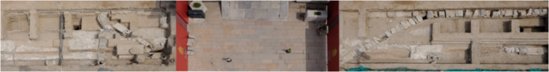
Panoramic view

We have found a lot of porcelain pit in the burial pit of the Ming and Qing Dynasty in the porcelain from the imperial kilns of the Qing Dynasty, at south of the Southern Warehouses (Nan daku).from the pipeline groove in the Southern Warehouses (Nan daku), we also found Jade stones and fragments of jadeware/Fragments of the Kapala (skull cup) and conches.

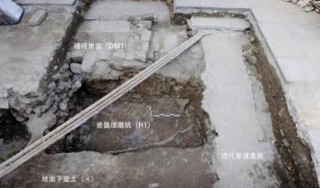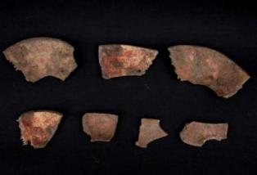
Terrace, tiled ground and porcelain pit in the excavation siteFragments of the Kapala (skull cup) unearthed from the pipeline groove (from south to north)

We have found the wall footing, ground and drains from the Ming Dynasty at the eastern wall east of the Southern Three Abodes (Nan san suo).
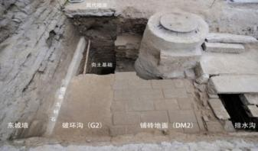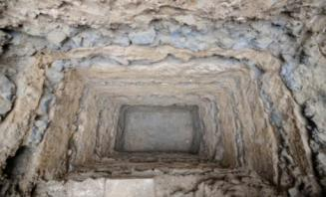
Wall footing, tiled ground and drainsA cross section exposing the strata of rammed earth base and immature soil

Architectural sites of the Ming and Qing dynasties was found in the eastern courtyard of the Garden of Compassion and Tranquility (Cininghuayuan).We restored plinths of the Ming and Qing dynasties. Besides, the archaeological site east of the Garden of Compassion and Tranquility (Cininghuayuan) have already been opened to the public.
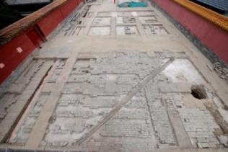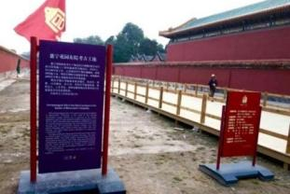
Panoramic viewof architectural sitearchaeological siteopen to the public

Strata and relics of the Yuan, Ming and Qing dynasties was found atthe east side of the Gate of Thriving Imperial Clan (Longzong men).The discovery of the Yuan-dynasty stratum is a milestone in the history of the Palace Museum and plays a significant role in studying the changes the Forbidden City.
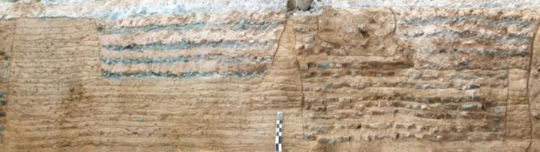
Northern wall of T0101 site trench west of the Gate of Thriving Imperial Clan (Longzong men)

Archaeological survey & mapping

The locations and the relics we have found are as follows:
 | Locations | Relics
1 | East side of the eastern wall of the Southern Three Abodes (Nan san suo) | Drains of the Ming and Qing dynasties
2 | North side of the southern wall of the Palace Kitchen Complex (Chashan fang) | Drain and ground of the Ming Dynasty
3 | Area east of the Gate of Gathering Happiness (Lianxi men) and to the south of the Thirteen Courtyards (Shisanpai) | Drain of the Ming and Qing dynasties
4 | Southwestern corner of the stone bridge to the west of the East Prosperity Gate (Donghua men) | Revetment and bridge base of the Qing Dynasty
5 | East side of the main hall of the Palace of Compassion and Tranquility (Cining gong) | Architectural site of the Ming Dynasty
6 | Southwest corner of the Left Gate of Good News (Huiyinzuomen) of the Palace of Compassion and Tranquility (Cining gong) | Strata of the Ming and Qing dynasties
7 | Southeast side of the Left Gate of Everlasting Health (Yongkangzuomen) | Strata of the Ming and Qing dynasties
8 | Northeast side of the Belvedere of Literary Profundity (Wenyuange) | Drains of the Qing Dynasty
9 | East side to the north of the Broken Rainbow Bridge (Duanhongqiao) | Architectural site of the Ming Dynasty
10 | Eighteen Chinese Scholar Trees north of the Broken Rainbow Bridge (Duanhongqiao) | Architectural site of the Ming Dynasty
11 | Waiting rooms east and west of the Gate of Correct Deportment (Duan men) | Architectural site of the Qing Dynasty
12 | South side of the southern wall of the Warehouse of Costumes (Xiyiku) | Architectural sites of the Ming and Qing dynasties
13 | East and south sides of the Ceremonial Weaponry Warehouse (Yizhangku) | Architectural sites of the Ming and Qing dynasties
14 | Area northwest of the Right-wing Gate (You yimen), to the east of the icehouse of the Imperial Household Department (Neiwufu) | Relics of the Gate of Maintained Tranquility (Baoning men) of the Ming Dynasty
15 | Northern wall (the northern garage) | Architectural site of the Qing Dynasty
16 | Area to the northwest of the screen wall south of the Southern Three Abodes (Nan san suo) | Ash pit of the Qing Dynasty
17 | West side of the western wall of the Southern Three Abodes (Nan san suo) | Ground of the Qing Dynasty
18 | Northwest corner of the Gate of Eternal Faith (Changxin men) | Architectural site of the Ming Dynasty

Locations of archaeological survey & mapping

Archaeology on the rooftop
Renovation project of the Grand Hall of the Supreme Profundity(Da gaoxuandian)

The Grand Hall of the Supreme Profundity (Da gaoxuandian), alternatively known as the Grand High Hall (Da gaodian) or the Grand Hall of Primacy (Da gaoyuandian) was built in the twenty-first year of the Jiajing reign (1522-1566) of the Ming dynasty (1644-1911). Located inside the imperial city of Beijing and next to the northwestern corner of the Forbidden City, the hall used to be the Taoist temple for the exclusive imperial use during the Ming and the Qing dynasties.
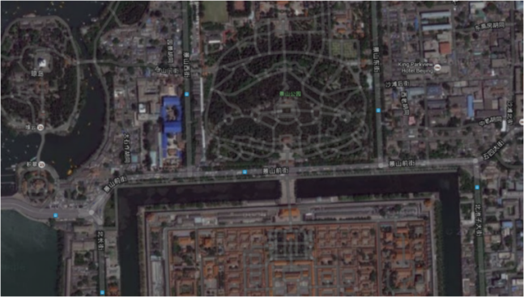
Location of the Grand Hall of the Supreme Profundity
The Palace Museum's first attempt to apply archaeological typological and stratigraphic ideas to historical architecture renovation, which highly positive results.

We had been introducing archaeological methods for the purpose of optimizing traditional architecture renovation techniques：analyzing, “excavating” and recording the information of the plaster layers with archaeological methods, dissecting the plaster layers of the northern roof slope of the Grand Gate of the Supreme Profundity (Da Gaoxuan men) with an “trail trenching” method. Renovation aided by plaster-layer sampling test and analysis. Classification and testing of roof-tile clay with methods of archaeological typology. Also, we had been comparing, recording, and studying Dougong bracket sets employing archaeological typology approach.

Part of our accomplishments:936 architecture drawings and 374 artifact drawings; 898 sacks of roof-tile clay, plaster and plaster-layer samples; 600 pieces of timber samples from individual buildings; 195 rubbings; 430G+ (over 40,000) photos.

Results and findings
We have special principles about the archaeological activities in relation to the Forbidden City: Archaeological studies follows the paces of the renovation project, to preserve the sites to the utmost with minimum intervention.“Minimally-invasive” excavation is conducted by making full use of sections of maintenance pits and trenches.Use patience and extreme caution upon the first sign of a site is revealed. Meticulous measures are taken to define the parameters, stratum position and nature of any site, while making sure that proper preservation measures are developed and implemented.The existing achievements have been well adopted in interdisciplinary cooperation and research.

Our results and findings:
What we have found under the forbidden city was mainly the strata of the Yuan (1272-1368), the Ming (1368-1644), and the Qing (1644-1911) dynasties, as well as the relics of architectural foundations, floor, drainage, palatial buildings, and bridges of the Ming and the Qing dynasties. In addition, there are some landfill sites (for wastes such as discarded ceramic objects and architectural components).The underground foundation of the Forbidden City is not monolithic, as legend has it. Instead, the foundation is composed of alternating strata of broken bricks/stones and loess, or of pure rammed earth. Foundations for large-scale palatial buildings sit on layers of rowed timber and rammed earth and is extremely solid.

The discovery of the Yuan-dynasty stratum is a milestone in the history of the Palace Museum and plays a significant role in studying the changes the Forbidden City, even the central axies of the city of Beijing underwent from the Yuan through to the Qing dynasties. The discovery is equally important for students of the history of theForbiddenCity and the history of traditional Chinese architecture.Discoveries of the architectural foundations enable us to glimpse the way the Forbidden City was built and the historical changes the complex went through. The landfill sites of discarded ceramic objects and construction wastes testify to the destiny of damaged objects after their being retired into storage, of which only scant documentation canbe found. They provide important first-hand materials for the study of the institution of imperial workshops of the Qing dynasty.

Introducing archaeological methods and approach into the renovation of the Grand Hall of the Supreme Profundity is an attempt to apply archaeological typology and stratigraphy to heritage architecture renovation. It is proved to be not only instrumental to the development of heritage architectural renovation techniques, but also a new way of putting archaeological theories and methodologies to practical use.

The Palace Museum is a window on the city of Beijing and on traditional Chinese urban planning principles.Guided by urban archaeology discoveries of the ancient capital of Beijing, the Palace Museum Archaeology Institute's excavation keeps pace with the Museum's annual infrastructure development to map out piece by piece the underground cultural relics of the Forbidden City. In the meantime, in-depth study is conducted to define the layout, structure, and correlation of the relics.Furthermore, archaeological theories and methodologies will be applied more extensively, while research will be conducted on excavation finds as well as objects from collections of the Palace Museum.

